**CG ASSIGNMENT-7(A)**

**PROGRAM**

**#include <stdlib.h>**

**#include <glut.h>**

**#include <iostream>**// including files

**using namespace std;**

**float xr = 0, yr = 0;** //to control the object’s movement

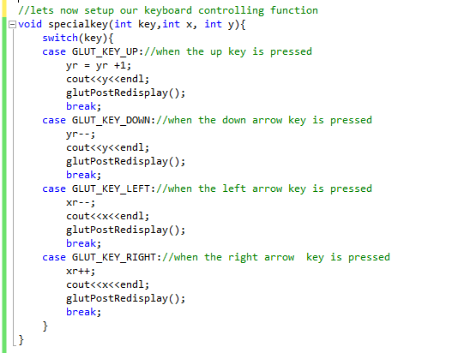

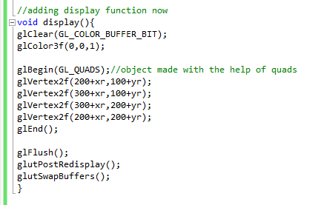

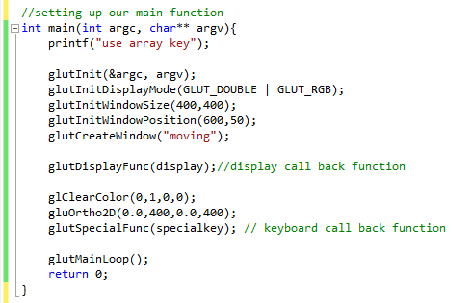

OUTPUT

